1. Bot will enter the URL - <https://publicaccess.caerphilly.gov.uk/PublicAccess/>

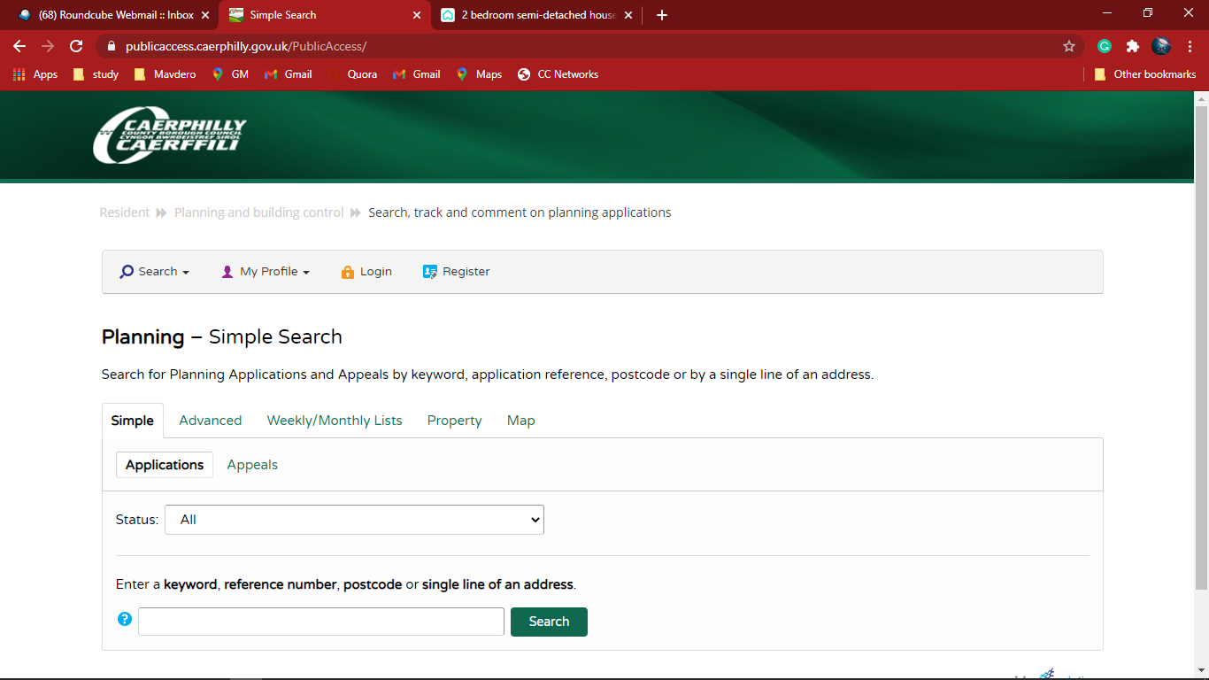

1. Bot Enter a keyword, postal code or single line of an address

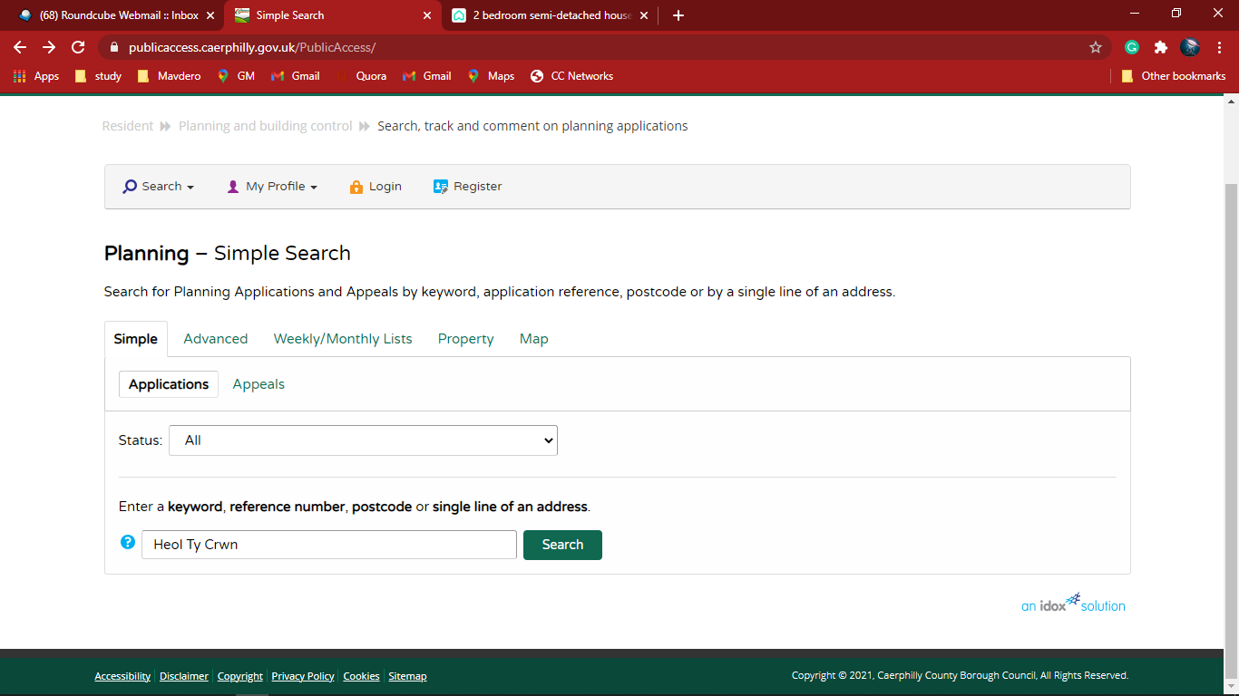

1. The Planning – Application summary will show as follow

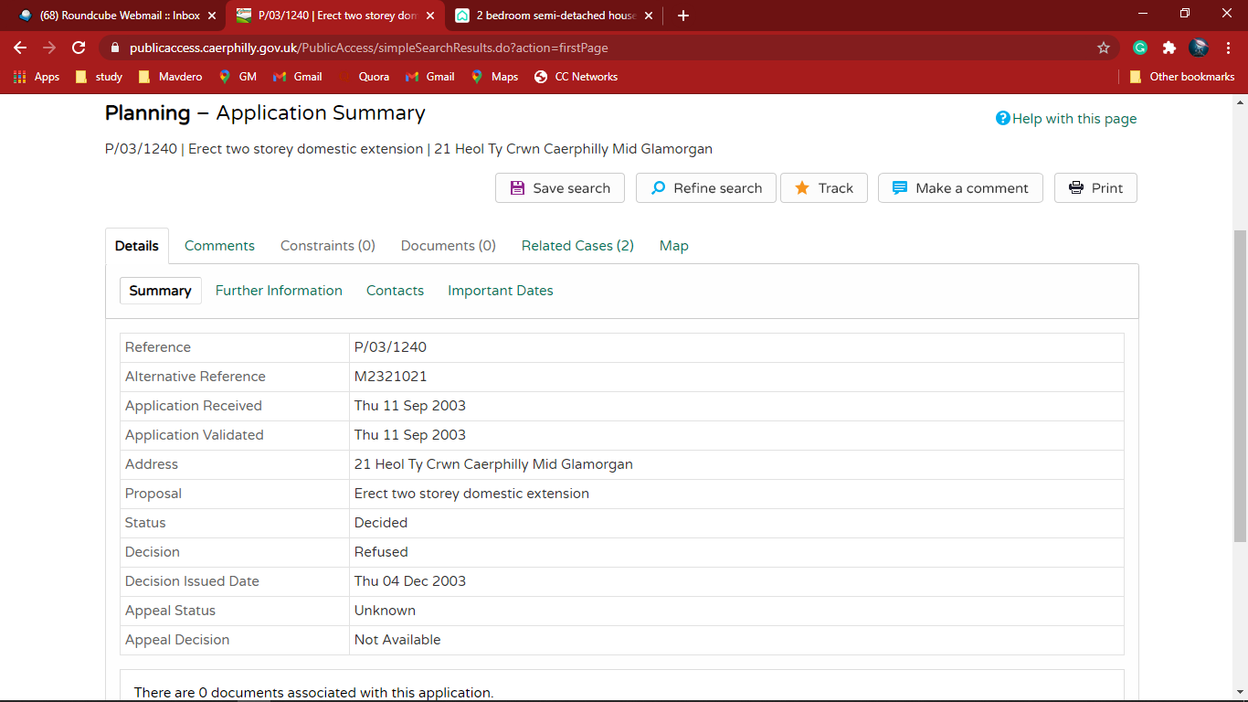

1. Bot will click and go to the Important dates

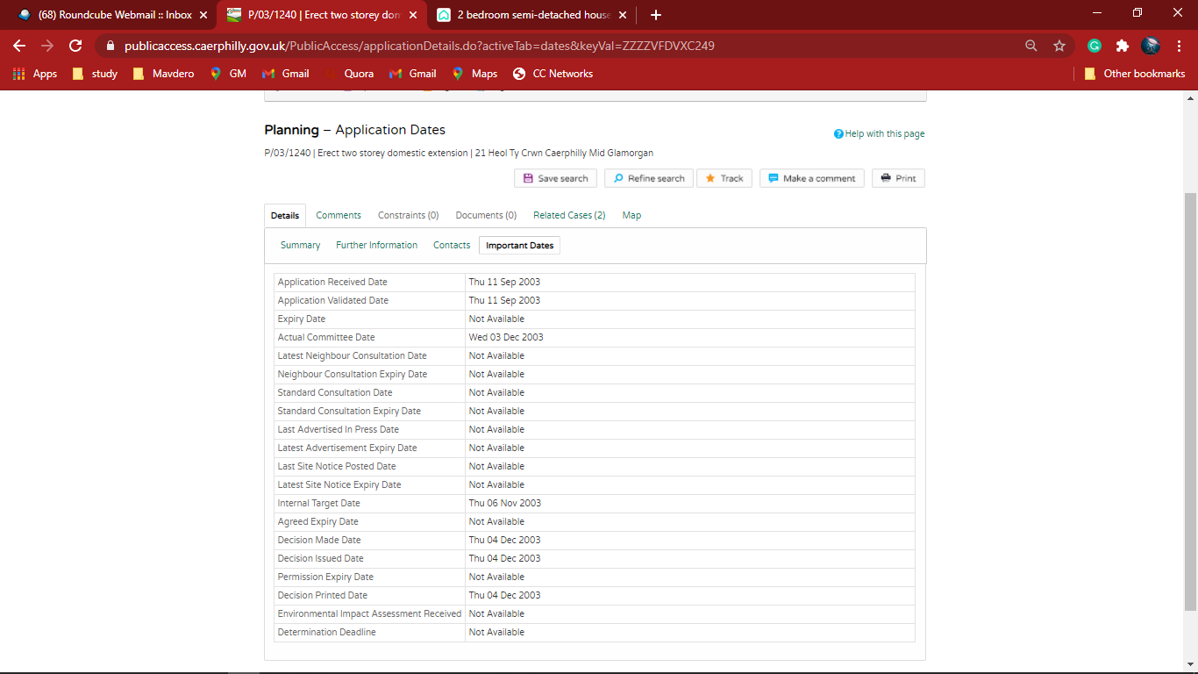

1. Bot will Extract the Data form Important Dates and Populate in Excel

